Part 1:

The code (written in C#.net core) for the WebApi is located at <https://github.com/angelinedai/SREInterview>

WebApi docker Image has been created in here, <https://hub.docker.com/r/angelinedai/sreinterview_forgerock_1>

Steps to build the docker image: *(You can download docker files* [*here*](https://github.com/angelinedai/SREInterview) *with the same file name as below.)*

1. Open powershell as admin
2. Nagvigate to the folder that contains docker file (same level as project sln file)
3. Run “*docker-compose build*” to build the image
4. You can use “*docker-compose up”* to test the webpage, <http://localhost:8080/api/StockPrice>.

(since this hasn’t run in Kubernetes cluster so only getting values from app settings in the project)

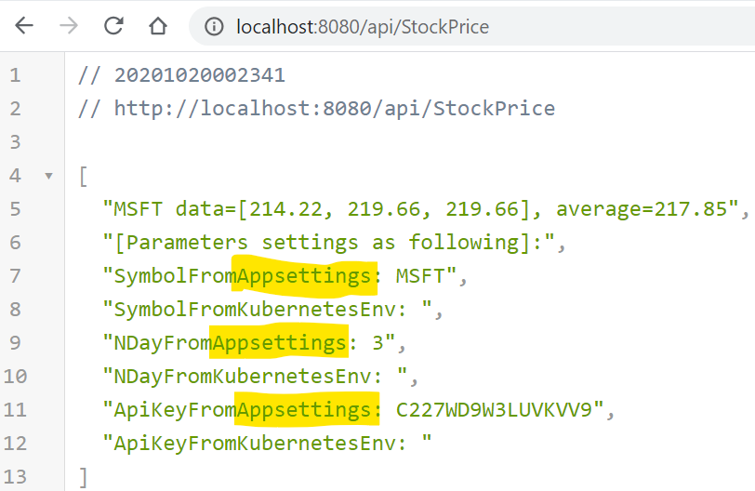

1. Run “*docker-compose down*” to shout down.
2. Run “*docker images”* (#check the image id to tag before push to docker hub)
3. Run “*docker tag e031a5969df6 {dockerusername}/sreinterview_forgerock_2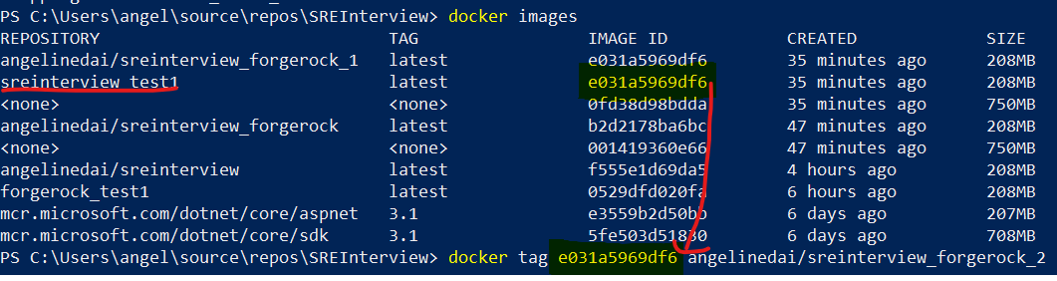*
4. Run “*docker push {dockerusername}/sreinterivew_forgerock_2*”
5. Check if the image has been updated to docker hub with your docker account

Steps to run the docker image and test the Rest API service:

1. Open powershell as admin, run the following line.

*docker run --name test55 -p 5555:80 -d {dockerusername}/sreinterview_forgerock_2*

1. Open the following url, <http://localhost:5555/api/StockPrice>.

(since this hasn’t run in Kubernetes cluster so only getting values from app settings in the project)

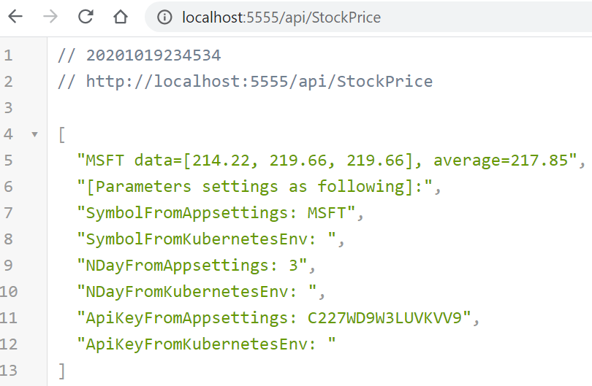

1. You can change to different stock for different ndays by modifying the url.

For example: http://localhost:5555/api/StockPrice/Symbol/TSLA/NDay/5

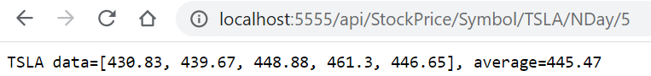

Part 2:

Steps to deploy service in Kubernetes: *(You can download all the yml files* [*here*](https://github.com/angelinedai/SREInterview) *with the same file name as below.)*

1. Open Command Prompt as admin
2. Navigate to the folder that contain the following yml files.
3. Run the following commands
4. minikube start --vm-driver hyperv (in windows)
5. kubectl apply -f [deployment.yml](https://github.com/angelinedai/SREInterview/blob/main/deployment.yml) (make sure the image is the same as what you just created)
6. kubectl apply -f [service.yml](https://github.com/angelinedai/SREInterview/blob/main/service.yml)
7. kubectl apply -f [configmap.yml](https://github.com/angelinedai/SREInterview/blob/main/configmap.yml)
8. kubectl apply -f [secret.yml](https://github.com/angelinedai/SREInterview/blob/main/secret.yml)
9. minikube addons enable ingress
10. kubectl apply -f [ingress.yml](https://github.com/angelinedai/SREInterview/blob/main/ingress.yml)
11. kubectl apply -f [nginxservice.yml](https://github.com/angelinedai/SREInterview/blob/main/nginxservice.yml)
12. minikube service forgerockinterview-service (then wait for it to show the url as below).

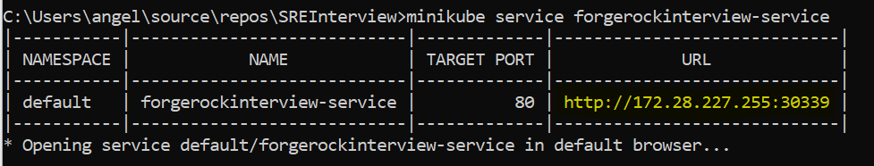

1. (if default browser isn’t open, please connect to the url as shown yellow highlighted part but since this has been using ingress facing. Please do NOT provide port number. The url should look like <http://172.28.227.255/api/StockPrice>.

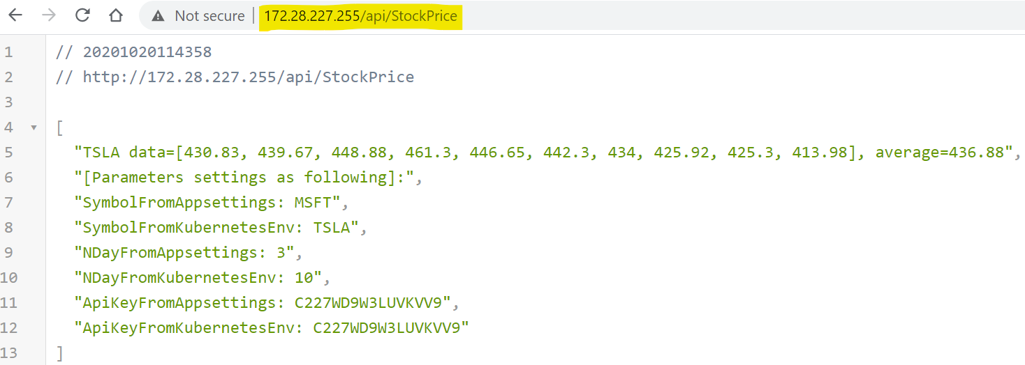

1. You can also test this with different symbols and ndays.

For example: <http://172.28.227.255/api/StockPrice/symbol/googl/nday/4>

